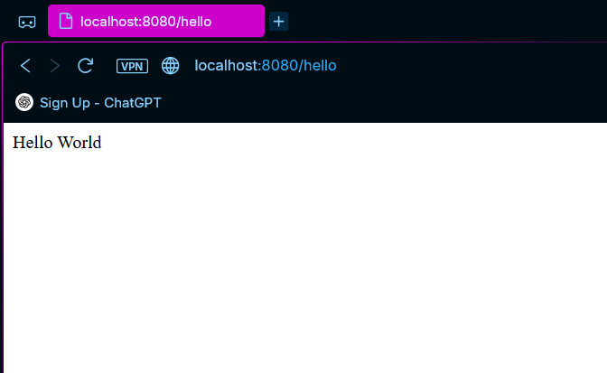
Fig 1.1 : /hello endpoint created which returns string “Hello World”

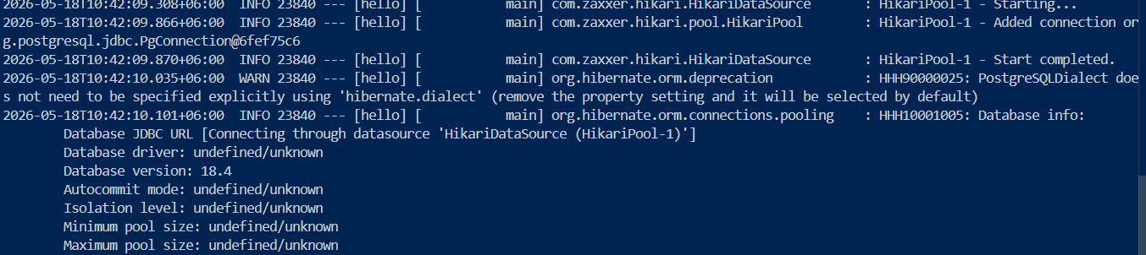
Fig 1.2: Successful database connection

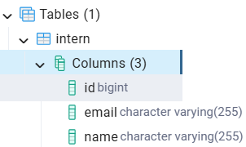
Fig 1.3: Table created successfully in the database intern_demo

